Kegitan 1

Berikut adalah program tidak lebih dari 20 baris yang saya buat :

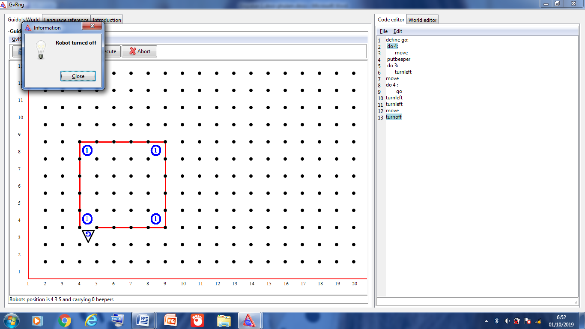

define go:

do 4:

move

putbeeper

do 3:

turnleft

move

do 4 :

go

turnleft

turnleft

move

turnoff

Kegiatan 2

Berikut adalah program tidak lebih dari 19 baris yang saya buat :

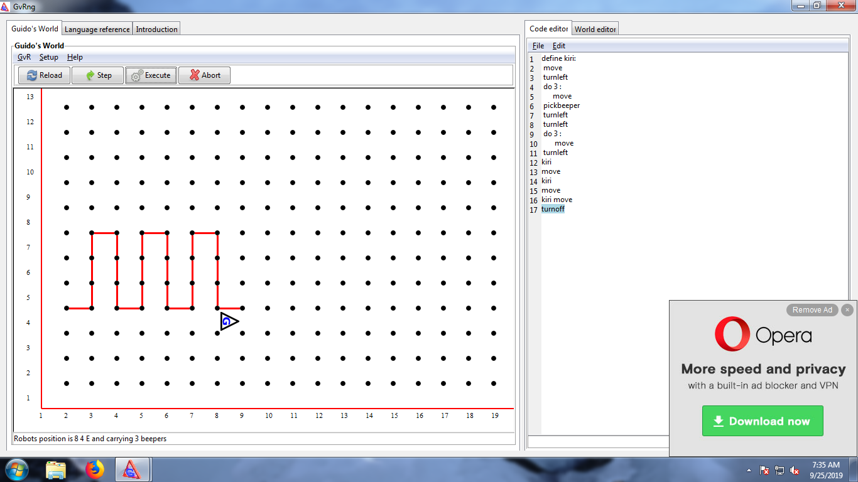

**Code**  word code

define kiri:

move

turnleft

do 3 :

move

pickbeeper

turnleft

turnleft

do 3 :

move

turnleft

kiri

move

kiri

move

kiri move

Turnoff

**word code**

robot 2 4 E 0

beepers 3 7 1

beepers 5 7 1

beepers 7 7 1

wall 2 4 N

wall 2 5 E

wall 2 6 E

wall 2 7 E

wall 3 7 N

wall 3 7 E

wall 3 6 E

wall 3 5 E

wall 4 4 N

wall 4 5 E

wall 4 6 E

wall 4 7 E

wall 5 7 N

wall 5 7 E

wall 5 6 E

wall 5 5 E

wall 6 4 N

wall 6 5 E

wall 6 6 E

wall 6 7 E

wall 7 7 N

wall 7 7 E

wall 7 6 E

wall 8 4 N

wall 7 5 E

**Kegiatan 3**

**Berikut adalah program yang elah dimodifikasi:**

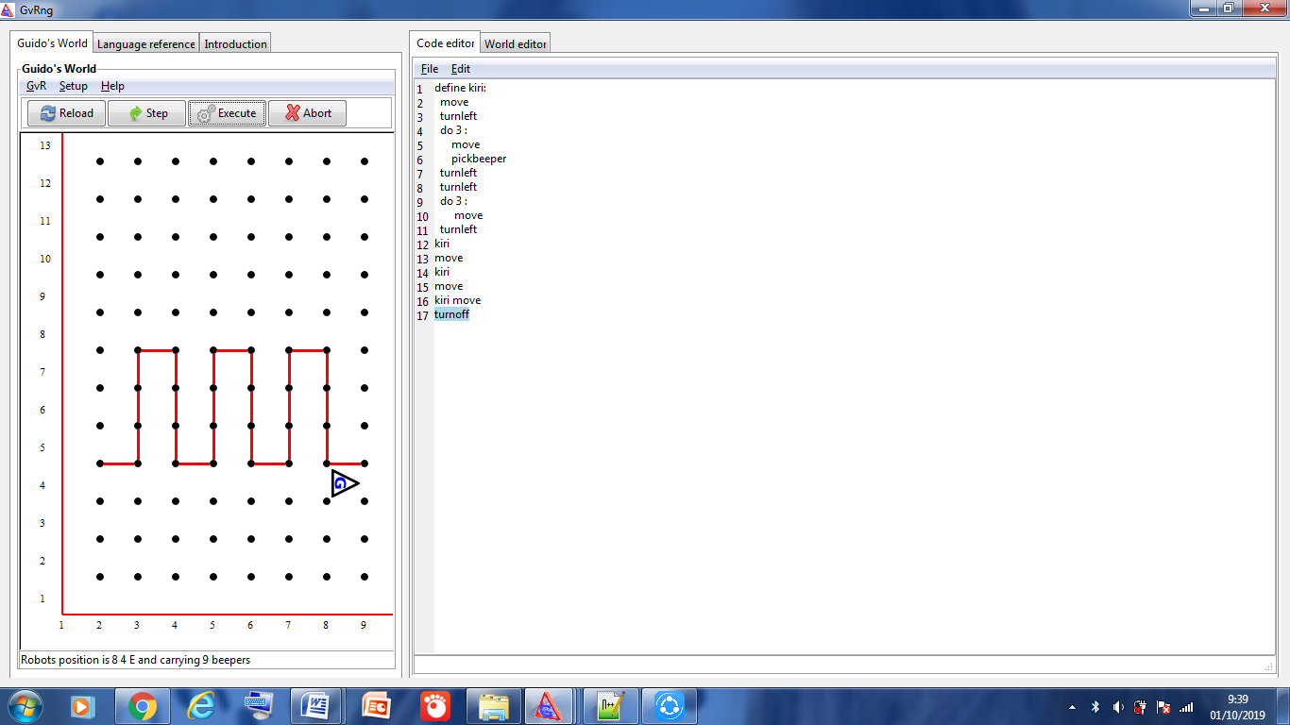

**Code**

define kiri:

move

turnleft

do 3 :

move

pickbeeper

turnleft

turnleft

do 3 :

move

turnleft

kiri

move

kiri

move

kiri move

turnoff

**Word code**

robot 2 4 E 0

beepers 3 5 1

beepers 3 6 1

beepers 3 7 1

beepers 5 5 1

beepers 5 6 1

beepers 5 7 1

beepers 7 5 1

beepers 7 6 1

beepers 7 7 1

wall 2 4 N

wall 2 5 E

wall 3 5 E

wall 3 6 E

wall 3 7 E

wall 2 7 E

wall 2 6 E

wall 3 7 N

wall 4 4 N

wall 4 5 E

wall 4 6 E

wall 4 7 E

wall 5 7 N

wall 5 7 E

wall 5 6 E

wall 5 5 E

wall 6 4 N

wall 6 5 E

wall 6 6 E

wall 6 7 E

wall 7 7 N

wall 7 7 E

wall 7 6 E

wall 7 5 E

wall 8 4 N

**kegiatan 4**

Berikut adalah screen shot window GvRng, sebelum program dijalankan

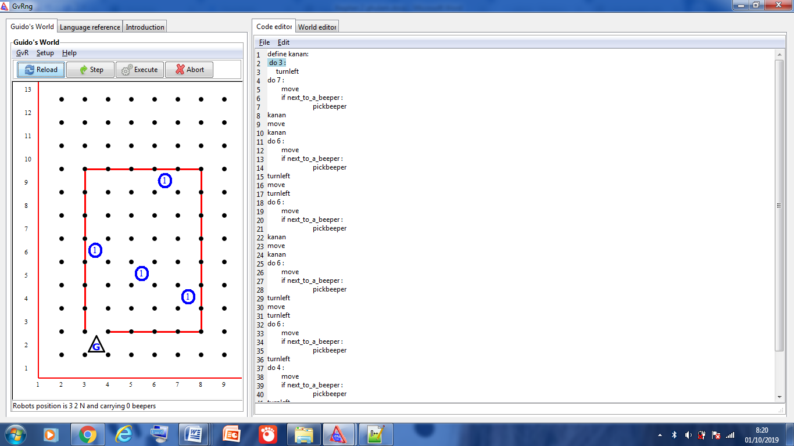

Berikut adalah screen shot window GvRng, setelah program dijalankan

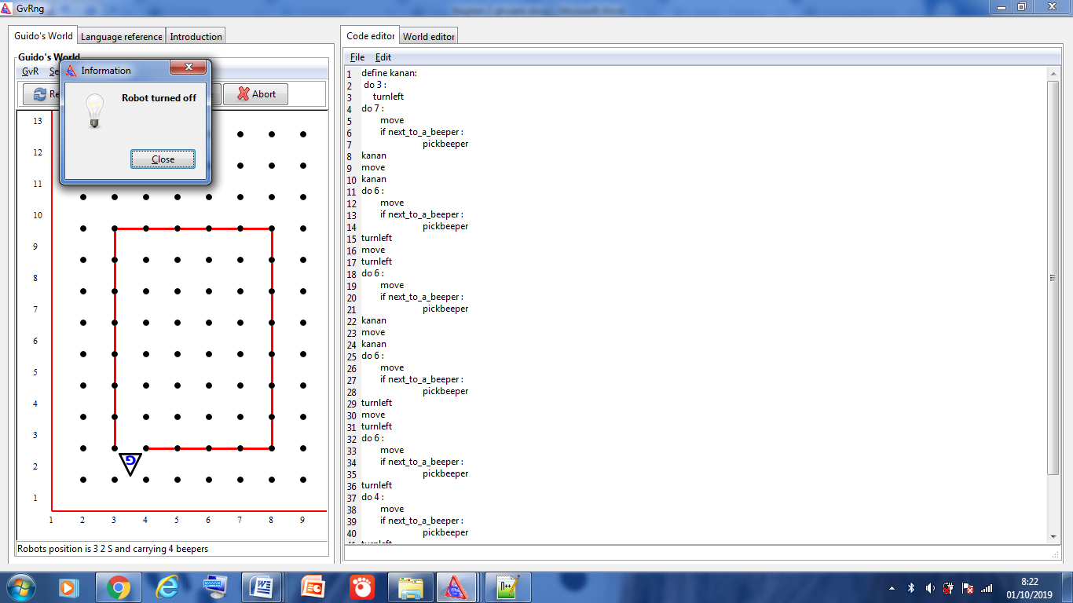

listing program adalah sebagai berikut:

code

define kanan:

do 3 :

turnleft

do 7 :

move

if next_to_a_beeper :

pickbeeper

kanan

move

kanan

do 6 :

move

if next_to_a_beeper :

pickbeeper

turnleft

move

turnleft

do 6 :

move

if next_to_a_beeper :

pickbeeper

kanan

move

kanan

do 6 :

move

if next_to_a_beeper :

pickbeeper

turnleft

move

turnleft

do 6 :

move

if next_to_a_beeper :

pickbeeper

turnleft

do 4 :

move

if next_to_a_beeper :

pickbeeper

turnleft

do 7 :

move

turnoff

word code

robot 3 2 N 0

beepers 3 6 1

beepers 5 5 1

beepers 6 9 1

beepers 7 4 1

wall 2 3 E

wall 2 4 E

wall 2 5 E

wall 2 6 E

wall 2 7 E

wall 2 8 E

wall 2 9 E

wall 3 9 N

wall 4 9 N

wall 5 9 N

wall 6 9 N

wall 7 9 N

wall 7 9 E

wall 7 8 E

wall 7 7 E

wall 7 6 E

wall 7 5 E

wall 7 4 E

wall 7 3 E

wall 7 2 N

wall 6 2 N

wall 5 2 N

wall 4 2 N